Ideation Phase

Define the Problem Statements

|  |  |
| --- | --- |
| Date | 04-November-2022 |
| Team ID | PNT2022TMID11798 |
| Project Name | Real time water quality monitoring and  control system |
| Maximum Marks | 2 Marks |

There are many means of drinking water. One among them is Groundwater. But is it safe to drink as such from the ground or using any sort of filtration? It may contain harmful toxins and not fit for drinking as such, it may lead to many diseases. Before using the groundwater, monitoring the quality of the water is the better solution. Using IoT we get to know whether it is consumable or not. We can also alert the user through Alert Message through the Mobile Application when the water reaches the threshold point. This project is aimed to monitor the quality of the borewell water for the use of household and drinking. Aims to check the pH, salinity, chlorine level in the borewell water.

# Customer Problem Statement Template:

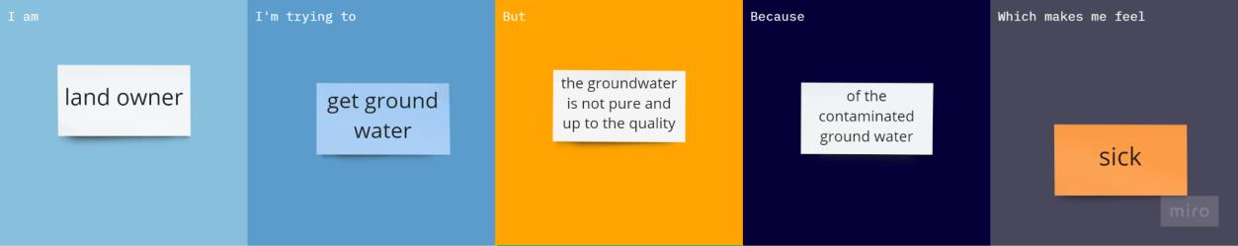

Reference link : [https://miro.com/app/board/uXjVPIVONoQ=/?moveToWidget=3458764537403559126&cot](https://miro.com/app/board/uXjVPIVONoQ%3D/?moveToWidget=3458764537403559126&cot=10)

[=10](https://miro.com/app/board/uXjVPIVONoQ%3D/?moveToWidget=3458764537403559126&cot=10)

# Example:

|  |  |  |  |  |  |
| --- | --- | --- | --- | --- | --- |
| **Problem Statement**  **(PS)** | **I am (Customer)** | **I’m trying to** | **But** | **Because** | **Which makes me feel** |
| PS-1 | Land owner | get ground water | the groundwater is not pure  and up to the quality | of the contaminated groundwater | sick |

|  |  |  |  |  |  |
| --- | --- | --- | --- | --- | --- |
| PS-2 | Farmer | Water the crops. (Groundwater) | The water is not having proper nutrients | Of less nutrients or rich in any one of the nutrients | unhealthy |